Summary of T.D. Replies
To Pension Levy Letter

Fine Gael

Enda Kenny:
I wish to acknowledge receipt of your email correspondence to the Taoiseach, Mr. Enda Kenny T.D. dated 29 June 2015.
Yours sincerely,
Michelle McKiernan
Assistant Private Secretary
to the Taoiseach
Telephone: 01-6194000
E-mail: privateoffice@taoiseach.gov.ie
Michael Noonan:
I acknowledge receipt of your email. Your correspondence will be brought to the attention of Mr. Michael Noonan TD, Minister for Finance and to the relevant officials in the Department of Finance. If the content of your correspondence relates to the functions of the Minister for Public Expenditure and Reform, Mr Brendan Howlin TD, it will be forwarded to his Office for attention.

Yours sincerely

Alex Lalor
Private Secretary to the Minister for Finance

Our Ref: 15/1854/MF

30 July 2015

Mr Tony Collins
[Tonycollins1@eircom.net]

Dear Mr Collins,

The Minister for Finance, Mr Michael Noonan TD, has asked me to respond to your correspondence regarding the pension fund levy.

The Minister confirmed in his Budget 2015 speech that the final 0.15% levy will expire at the end of 2015.

The chargeable persons for the pension fund levy are the trustees or other persons (including insurance companies) with responsibility for the management of the assets of the pension schemes or plans. The payment of the levy is treated as a necessary expense of a pension scheme and the trustees or insurer, as appropriate, are entitled, where they decide to do so, to adjust current or prospective benefits payable under a scheme to take account of the levy. It is up to the trustees to decide whether and how the levy should be passed on and who should be impacted and to what extent, given the particular circumstances of the pension schemes for which they are responsible. While the levy itself will expire at the end of 2015 the manner in which the trustees choose to pass it on may entail a longer term but lesser reduction in pension payments. However, should the option of reducing scheme benefits be taken, in no case may the reduction in an individual member’s or class of member’s benefits exceed the member’s or class of member’s share of the levy.

While the final pension fund levy will be ceased as outlined, the Minister has no plans to repay the pension fund levy collected as you suggest. The value of the funds raised by way of the levy have been used to protect and create jobs and this has helped to create the improving financial and economic position of the State. Taxpayers to whom the impact of the levy may have been passed on by the chargeable persons for the levy will benefit from the changes which the Minister began in Budget 2015 and which will continue in future Budgets to reduce the tax burden on low and middle income earners.

Yours sincerely,

___________________
Alex Lalor
Private Secretary

To: Michael Noonan TD, Minister for Finance
3rd August 2015

Re: Government Pensions Levy
Dear Minister,
Thank you for your response dated 30th July 2015 to my letter dated 29th May 2015.
You have failed to address the main issue raised in my letter. Whether or not the Trustees of a Pension Fund decide to recover the cost of the Government Levy from Scheme members is not the main trust of my letter. The inherent injustice of the confiscation of Pensioners savings is the main issue here and the fact that this Government passed this outrageous legislation in 2011 to enable them to raid the savings of a weaker sector of society to the tune of €2.2 billion over a four year period. The raid on Pension Funds will be discontinued at the end of this year but many pensioners, however, are now coming to the realisation that they will pay the levy for the rest of their natural lives. This will be the current Government’s legacy and will be remembered by all who were affected by it.
To add further insult, the Government are proposing to refund the pension levy on public sector staff and pensioners over the next few years and you have clearly stated in your response that you have no plans to reimburse the levy on private Pension Funds. This inequitable treatment of pensioners as a group is totally unacceptable. You have also targeted the elderly when you introduced measures in Budget 2013 that abolished the telephone allowance for OAP’s and the Bereavement Grant. You have introduced a five-fold increase in prescription charges since entering office and have reduced income thresholds for medical cards twice in that period. The Government have maintained that they have not reduced the State Pension yet since they came into office they have changed the qualifying criteria for the State Pension making it increasingly difficult for individuals to obtain a full pension.
You have also removed tax relief for private medical insurance premiums, introduced charges in public hospital wards for those with private health insurance, which has substantially increased the cost of private health insurance making it impossible for many individuals to continue with private medical cover.
These are election issues and I can assure you Minister, that they will be pursued vigorously in the coming months by ESB Retired Staff Association, who represent the interests of the majority of ESB’s 7,500 pensioners. May I also remind you, Minister, of the size of the “Grey Vote”. The CSO’s Population Growth Scenarios have predicted that 24% of the population will be over 60 in 2016, Election Year. This is more than 1 million, which translates to approx 33% of the total electorate of 3.2 million. The over 60’s are a sector of society who do actually vote in General Elections and will have the power to decide the overall outcome of the Election. Our Association will continue to publicise the real facts surrounding the Levy through our public website www.esbrsa.ie and through a multitude of other channels available to us.
Yours sincerely,
Tony Collins
Chairman National Executive
ESB Retired Staff Association
Mob 086 8197083

Olivia Mitchell:
Thank you for your email. I want to assure you that I am very aware of the long term impact of the pension levy and have spoked against it on a number of occasion in Dáil Éireann (see attached) and I certainly opposed the extension of the levy until this year.
While I fully understand that that money is gone forever and consequently its earning power going forward. I very much doubt that that money will be restored. It was very much a financial emergency measure and while extremely onerous it is also true to say that in terms of public spending pensioners are protected more than most during the financial crisis. Every country in a situation like ours took unpalatable measures. For instance, in Cyprus people's bank accounts were raided. Nevertheless, I do accept that the message that pension funds are vulnerable is not a good one at a time when we're otherwise trying to encourage people to provide for their future.
Kind Regards,
Olivia

Dinny McGinley:
I acknowledge receipt of your e-mail with attached letter re the above.
This is being brought to the attention of Deputy McGinley.
Yours sincerely,
Bridie Sheahan
Personal Assistant
Sean Barrett:
I wish to acknowledge receipt of your email of 29/06/2015 to me in relation to your members' right to be represented, together with the need for legislation which would grant 'parity of esteem' to 'former workers' regarding the State's Industrial Relations machinery, and effect of the 'Pensions Levy' on Private Pensions.
I trust you will understand that due to my position as Ceann Comhairle, I am unable to become involved in matters concerning Legislation or Government Policy. However, I have forwarded your email to the Minister for Finance, Michael Noonan TD, for his consideration.
Thank you for writing to me with your views.
Kind regards.
Sean Barrett TD
Ceann Comhairle, Dáil Éireann
Jim Daly:
Just a note to confirm receipt of your email below, I will ensure to bring same to Jim's attention.
Regards,
Darren Hourihane
Parliamentary Assistant to Jim Daly TD
Jim Daly T.D
Leinster House
Kildare Street
Dublin 2
01 6183886
jim.daly@oir.ie
Mary Mitchell O Connor:
I wish to acknowledge receipt of your email to the Office of Mary Mitchell O'Connor TD who represents the Dún Laoghaire constituency.
I will bring your correspondence to the attention of the Deputy at the earliest opportunity.
I look forward to being in contact with you.
Yours sincerely,
Jacqui
Secretarial Assistant
Mary Mitchell O'Connor TD
Dáil Éireann
Leinster House
Kildare St.
Dublin 2
Richard Bruton:
I acknowledge receipt of your email to Minister for Jobs, Enterprise and Innovation, Mr. Richard Bruton T.D..
I will bring your correspondence to the Minister’s attention at the earliest opportunity.
Yours sincerely
Thérèse Walsh
Private Secretary
Office of Minister Richard Bruton T.D.
Department of Jobs, Enterprise & Innovation | 23 Kildare Street, Dublin 2
Tel: +353 1 631 2172 | minister@djei.ie | http://www.enterprise.gov.ie/en/
Dara Murphy:
Thank you for your email.
I will bring it to Minster Murphy's attention.
Kind Regards
Kieran Murphy
Personal Assistant to Minister Dara Murphy TD
Regards
Dara Murphy TD
Minister for European Affairs and Data Protection
Fine Gael
Cork North Central
Camden House
Camden Quay
Cork
Constituency Office: 021 - 4559353
Email: dara.murphy@oireachtas.ie
Bernard Durken:
Many thanks for contacting me once again in relation to ESB pensioners.
I have contacted the Minister for Finance on your behalf regarding same and I await his response.
If and when reply is to hand, I will be in contact with you again. Failing response within a reasonable period, you might remind me so that a successful conclusion can be reached.
Yours sincerely,
Bernard J Durkan TD
Jimmy Deenihan:
Dear Carl,
Please find attached correspondence that I have received from Joan Burton TD., Minister for Social Protection, following my representations on your behalf. I will be back in touch with you as soon as I receive a further update from Minister Burton.
In the meantime if you require further assistance, please do not hesitate to contact me.
Kind regards,
Margaret
on behalf of
Jimmy Deenihan TD
Minister for Diaspora Affairs
Joe O Reilly:
Thank you for your email.
I have made representations to Minister Noonan on behalf of the ESB Retired Staff Association and, when I receive his response, I will be back in touch with you.
Kind regards.
Joe O'Reilly, TD
Leinster House
Dublin 2.

Labour:
Kathleen Lynch:
I wish to acknowledge receipt of your email below, the contents of which will be brought to Kathleen's attention.
Regards
Sara
Sara Mongan (Personal Secretary)
Constituency Office of Kathleen Lynch T.D.
Minister of State for Primary Care, Social Care (Disabilities & Older People) and Mental Health
1st Floor,
Heron House,
Blackpool Retail Park,
Blackpool,
Cork.
Tel:021 4399930
021 4212463
Fax:021 4215060
Email: kathleen.lynch@oir.ie
www.labour.ie
Dear Carl,
(See attached file: Carl O'Sullivan 001.jpg)(See attached file: Carl O'Sullivan 002.jpg)
Further to previous correspondence please now find response I received today from Ms. Joan Burton TD, Tanaiste and Minister for Social Protection.
Kathleen Lynch
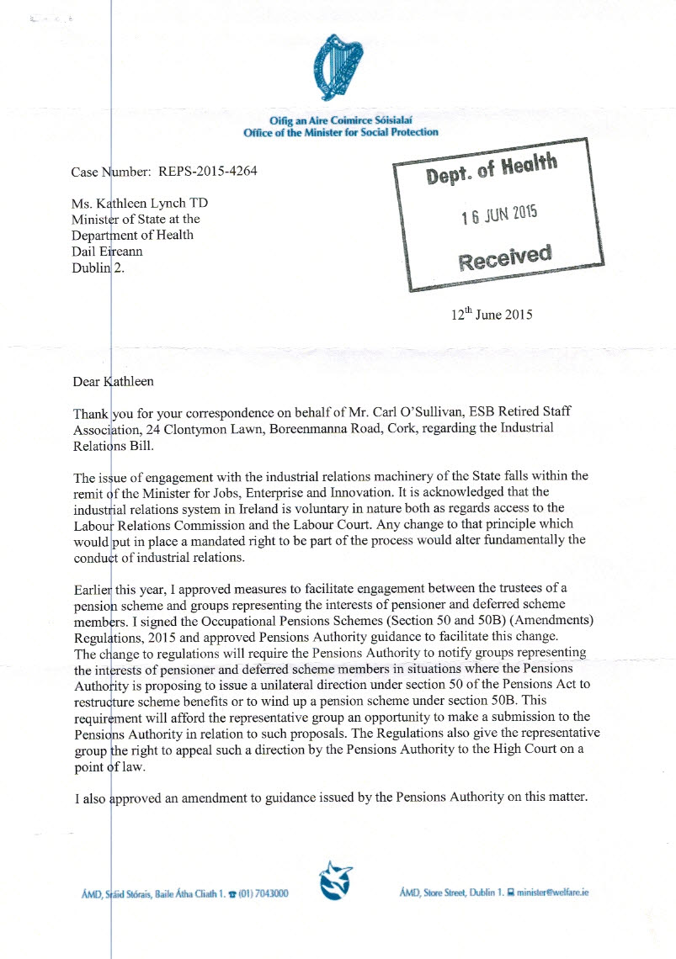
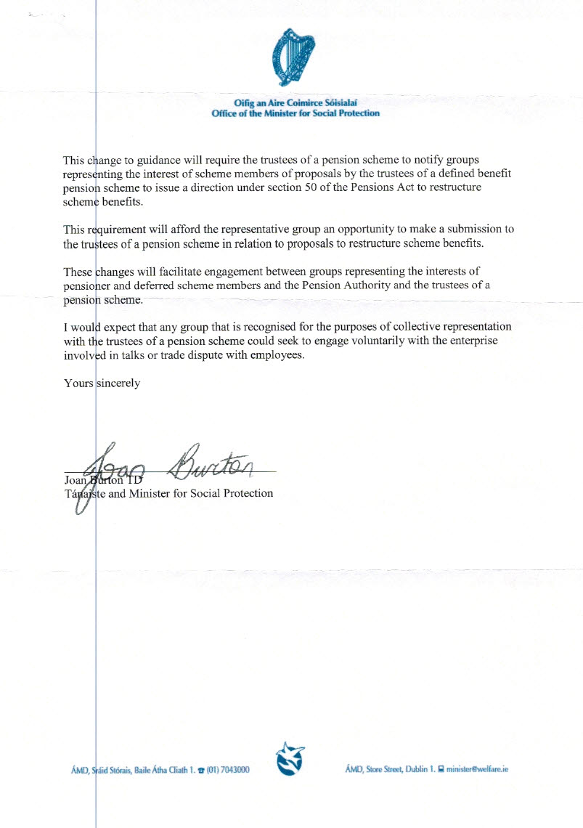
Ciaran Lynch:

Thank you for your correspondence on behalf of the ESB Retired Staff Association and related pension matters along with included correspondence from Minister Noonan in respect of same.

As mentioned in my earlier responses to date to your correspondence, I am available to meet at my office to discuss these matters and should you wish to do so please give my office a call to arrange a suitable time.

Once again thank you for your email and for continuing to keep me informed on these matters.

Best wishes

Ciarán
Ciarán Lynch TD
Constituency Office
29 St. Patrick's Mills
Douglas
Cork
Ireland
Tel: 00353214366200
Fax: 00353214366200
ciaran.lynch@oir.ie
www.ciaranlynch.ie
Eamonn Maloney:
Thank you for your email which I will bring to Éamonn's attention at the earliest opportunity.
Yours sincerely
Tracy Young
Personal Assistant.
ÉAMONN MALONEY, T.D.
DÁIL ÉIREANN
KILDARE STREET
DUBLIN 2.
TEL: 01-6184833

Dominic Hannigan:
Thank you for your email outlining the concerns of your members.
I will bring this to the attention of the Tánaiste so that she is aware of it as well as my Labour colleague Minister Ged Nash who is in the Department of Jobs.
Best wishes,
Dominic

Eamon Gilmore:
I have contacted the Minister's office and asked that they communicate directly with you to arrange a meeting.
Yours sincerely
Eamon Gilmore TD
Brendan Howlin:
I acknowledge receipt of your email. Your correspondence will be brought to the attention of Minister Brendan Howlin T.D., Minister for Public Expenditure and Reform and to the relevant officials within the Department.
Yours sincerely,
Michelle O’Connor
Private Secretary to the Minister
Ref 15/0078/PER

10 July 2015

Mr. Carl O Sullivan
ESB Retired Staff Association
Email: clonty@eircom.net

Dear Mr O’Sullivan

The Minister for Public Expenditure and Reform Mr. Brendan Howlin TD has asked me to refer to your recent email on behalf of the ESB Retired Staff Association in relation to pension matters. As previously advised the pension fund levy is a matter under the responsibility of the Minister of Finance.

The chargeable persons for the pension fund levy are the trustees or other persons (including insurance companies) with responsibility for the management of the assets of the pension schemes or plans. The payment of the levy is treated as a necessary expense of a pension scheme and the trustees or insurer, as appropriate, are entitled, where they decide to do so, to adjust current or prospective benefits payable under a scheme to take account of the levy. It is up to the trustees to decide whether and how the levy should be passed on and who should be impacted and to what extent, given the particular circumstances of the pension schemes for which they are responsible. However, should the option of reducing scheme benefits be taken, in no case may the reduction in an individual member's or class of member's benefits exceed the member's or class of member's share of the levy.

The matter of representation by pensioner groups in consideration of a change to scheme benefits is a matter for the Minister for Jobs, Enterprise and Innovation and the Minister for Social Protection. This matter has already been referred to them for consideration.

Yours sincerely

Michelle O’Connor
Private Secretary
Minister for Public Expenditure and Reform

Ruiri Quinn:
01/07/2015
Thank you for your email.
I have contacted both the Minister for Social Protection, Joan Burton TD. and the Minister for Jobs, Enterprise and Innovation, Richard Bruton TD. regarding this matter and I will be in touch as soon as I have received a response.
I appreciate your correspondence on this issue.
Regards,
Ruairí
Ruairí Quinn TD
Leinster House
Tel 01 618 3912
Email: ruairi.quinn@oireachtas.ie
Ciara Conway:
I wish to acknowledge receipt of your email .
Thank you for contacting me and I will be in touch with a further response in due course
Kind regards,
Ciara.
Deputy Ciara Conway
Labour T.D. for Waterford
Vice-Chair Joint Oireachtas Committee on Health and Children
Contact : 01 618 4011
ciara.conway@oir.ie
Constituency Office:
36 Mary Street, Dungarvan, Co Waterford
Contact: 058 245 14

Emmet Stagg:
Thank you for your email received.
I have forwarded your correspondence to the Ministers and I will advise you of any reply received.
Yours sincerely,
Emmet.

Dear Carl,
Please find enclosed the reply I have received in response to representations I made on your behalf and which is self explanatory.
Yours sincerely,
Emmet M. Stagg T.D.

Fianna Fail:

Michael Martin:

We wish to acknowledge receipt of your email.
Yours sincerely,
The Office of Micheál Martin T.D.

Michael McGrath:

Thanks very much Carl, I will reply once the email is sent out.
Kind regards,
Michael McGrath T.D.
Constituency Office
Main Street
Carrigaline
Co Cork
Tel no: 021 4376699
Fax no: 021 4834252
Fianna Fáil Spokesperson on Finance

Timmy Dooley:

Sent on behalf of Timmy Dooley TD
Just a short note to acknowledge your recent e mail and to confirm that I have made strong representations to both the Minister for Jobs, Enterprise and Innovation Richard Bruton TD and the Minister for Social Protection, Joan Burton TD requesting former workers be afforded the same rights as workers and legislation be introduced requiring former Employers to engage with representative bodies for former workers on all matters relating to their original contracts of employment and pension matters.
I will continue to pursue the matter and keep you updated in due course. In the meantime, please feel free to call my office on this or other issues.
Yours sincerely,
Timmy Dooley
_______________________
Timmy Dooley TD
Spokesperson for Transport, Tourism and Sport & Clare Fianna Fáil TD
Dáil Éireann, Leinster House, Kildare Street, Dublin 2
Constituency Office: 8 Mill Road, Ennis, Co. Clare
Tel: 065 6891115
Fax: 065 6891116
e mail: timmy.dooley@oireachtas.ie
web: www.timmydooley.ie

when I receive further information. In the meantime, please feel free to call my office on this or any matter.
Yours sincerely,
Timmy Dooley
_______________________
Timmy Dooley TD
Spokesperson for Transport, Tourism and Sport & Clare Fianna Fáil TD
Dáil Éireann, Leinster House, Kildare Street, Dublin 2
Constituency Office: 8 Mill Road, Ennis, Co. Clare
Tel: 065 6891115
Fax: 065 6891116
e mail: timmy.dooley@oireachtas.ie
web: www.timmydooley.ie
From: Joan Burton <Joan.Burton@welfare.ie>
To: Emer Dooley <Emer.Dooley@Oireachtas.ie>,
Cc: Office of the Minister for Social Protection <Minister@welfare.ie>
Date: 29/06/2015 13:06
Subject: RE: Pension Levy

Dear Timmy,
On behalf of the Tánaiste and Minister for Social Protection, Joan Burton TD I wish to acknowledge receipt of your representations, dated 29/6/2015.
I will bring your email to the attention of the Private Office of An Tánaiste at the Dept of Social Protection for direct reply.
Yours sincerely
Colm Lawless
Office of Joan Burton, T.D.
Tánaiste, Minister for Social Protection & Leader of the Labour Party
Email: joan.burton@welfare.ie
Ph: 01 6184006
www.joanburton.ie

Sent on behalf of Timmy Dooley TD
Please see below interim reply from the office of the Minister for Jobs, Enterprise & Innovation, Richard Burton TD in relation to my recent representations on your behalf.
I will be in contact with you again when I receive further information.
In the meantime, please feel free to call my office on this or any matter.
Yours sincerely,
Timmy Dooley
_______________________
Timmy Dooley TD
Spokesperson for Transport, Tourism and Sport & Clare Fianna Fáil TD
Dáil Éireann, Leinster House, Kildare Street, Dublin 2
Constituency Office: 8 Mill Road, Ennis, Co. Clare
Tel: 065 6891115
Fax: 065 6891116
e mail: timmy.dooley@oireachtas.ie
web: www.timmydooley.ie
----- Forwarded by Emer Dooley/Polstaff/Oireachtas on 03/07/2015 12:28 -----
From: minister@djei.ie
To: Emer Dooley <Emer.Dooley@Oireachtas.ie>,
Date: 30/06/2015 15:43
Subject: Re: Pension Levy
Sent by: Carol.Toolan@djei.ie

Dear Deputy Dooley
I acknowledge receipt of your email to Minister for Jobs, Enterprise and Innovation, Mr. Richard Bruton T.D..
I will bring your correspondence to the Minister’s attention at the earliest opportunity.
Yours sincerely
Thérèse Walsh
Private Secretary
Office of Minister Richard Bruton T.D.
Department of Jobs, Enterprise & Innovation | 23 Kildare Street, Dublin 2
Tel: +353 1 631 2172 | minister@djei.ie | http://www.enterprise.gov.ie/en/

Willie O Dea:
Thank you for your email. As you know I have been working on the Pension issue for some time now. I am proposing to change the Priority Order for payment of pensions under the Defined Benefit Pension Schemes. I am proposing that anyone who qualifies for a pension on the basis that they have reached retirement age will lose half the amount by which their pension exceeds 30K per annum. This would mean that the balance would be divided amongst people who have not reached retirement age in the event of the scheme being wound up. I am also proposing that a firm which is solvent will not be allowed to close down a Defined Benefit Pension Scheme except where the scheme has reached a minimum of 90% funding standard. All of the information is set out in the Pensions Amendment Bill 2013 which I attach for your information and is available to download at http://www.oireachtas.ie/documents/amendments/2013/b5413d-dc2.pdf ).
If I can be of assistance to you in the future please do not hesitate to contact me.
Yours sincerely
Willie O'Dea T.D.

John Browne:
I will again raise the matter with Minister Joan Burton and I will forward her reply as soon as I receive same.
Regards
John.

Please see attached a reply I have received from Minister Burton T.D. for your perusal. Please let me have your comments on the matter.
(See attached file: img705.pdf)
Kindest regards
John

Got pension fund mixed up.

Michael Moynihan:

I wish to acknowledge your recent email, and thank you for contacting me about this matter.

I have made representations on your behalf to both the Minister for Social Protection and the Minister for Job, Enterprise and Innovation, asking both Ministers if they would meet with you to discuss these issues. I will continue to do my best to highlight and support these issues at every opportunity, and I will let you know as soon as I receive a response from either Minister.

In relation to the Private Pension Levy, the Government previously pledged that this levy would end in 2014, however they have reneged on that promise. Fianna Fáil has repeatedly called for the ending of this extremely unjust levy.

This pension levy will result in pension scheme members having lower pensions, and is punishing prudent savers. The Government has very cynically calculated that many people are oblivious to this tax because they don't have access to their pension savings now. My colleague Michael McGrath TD, Fianna Fáil spokesperson for Finance, who has been raising this issue repeatedly with Minister Michael Noonan, has labelled this levy as the most daring financial smash-and-grab by any government in the history of the State.

We will continue to put as much pressure as possible on the Government regarding this issue, and I have conveyed your thoughts on this matter to Michael McGrath TD also.

I trust that this is in order and please don't hesitate to contact me if you wish to discuss this matter further.

Kind regards,

Michael Moynihan TD
Fianna Fáil spokesperson on Communications, Energy & Natural Resources

On 29 June 2015 at 15:00, Michael Moynihan

Dear Carl,

Please find enclosed email received from Minister Richard Bruton on this matter for your information.

I will revert to you as soon as I receive a response from Minister Noonan on this issue, and we will continue to pursue this matter with the Government at every opportunity.

Kind regards,

Michael Moynihan TD
Fianna Fáil spokesperson on Communications, Energy & Natural Resources

---------- Forwarded message ----------
From: <minister@djei.ie>
Date: 20 July 2015 at 10:53
Subject: Re: Fwd: Fw: Pension Levy
To: Michael Moynihan <michael@michaelmoynihantd.ie>
Our Ref: 151162/MIN
Dear Michael,
I refer to your recent correspondence on behalf of the ESB Retired Staff Association (ESBRSA).
With regard to collective representation access rights for the ESB retired workers to the industrial relations machinery of the State, this is an issue to which I have given careful consideration.
The industrial relations system in Ireland is voluntary in nature, any change to that principle which would put in place a mandated right to be part of the process would alter fundamentally the conduct of industrial relations. As it stands, where changes to pension schemes are negotiated at company level, whether as a result of a crisis in the scheme or otherwise, the outcome of that engagement cannot, of itself, change the pension scheme. Rather, any proposed changes to the scheme are effected through the trust deeds and rules of the scheme and are at the discretion of the parties so designated in the rules/deeds of the scheme. In my view, it is within this framework, rather than through the State’s industrial relations machinery, that a collective approach would be most effective.
In this context, I welcome the recent decision of the Tánaiste and Minister for Social Protection to provide for the recognition by trustees and the Pensions Authority of groups representing the interests of retired and deferred scheme members of a particular pension scheme and affording the representative group an opportunity to make a submission to the trustees of the scheme in relation to proposals to restructure such schemes.
Officials from my Department have met with the members of the executive council of the ESBRSA on a number of occasions in recent months. Subsequent to the last meeting in April, a submission setting out the Association’s issues in detail was sent to this Department for consideration with a view to the Association meeting with me. It is anticipated that such meeting can be arranged in the coming weeks.
As the substantive issue raised in the correspondence is in relation to the Pension Levy, and this matter falls within the remit of Mr. Michael Noonan T.D., Minister for Finance, I have forwarded your correspondence to his Office for attention and direct reply to you.
Yours sincerely,
RICHARD BRUTON T.D.
MINISTER FOR JOBS ENTERPRISE AND INNOVATION
Office of Minister Richard Bruton T.D.
Department of Jobs, Enterprise & Innovation | 23 Kildare Street, Dublin 2
Tel: +353 1 631 2172 | minister@djei.ie | http://www.enterprise.gov.ie/en/

Sinn Fein:

Gerry Adams:

Thank you for your mail to Gerry Adams TD
We wish to acknowledge receipt of your correspondence.
Go raibh maith agat as do theachtaireacht chuig Gearóid Mac Ádhaimh TD.
Ba mhaith linn ár mbuíochas a ghabáil leat tar éis dul i dteagmháil linn.
Le meas,
Office of Gerry Adams TD
Sinn Féin President
Kildare St
Dublin 2

Caoimhghin O Caolain:
Many thanks for your email. I will forward to the party spokesperson Teachta Peadar Tóibín.
With kind regards,
Is mise,
Caoimhghín Ó Caoláin T.D.
Sinn Féin Spokesperson on Health
Dessie Ellis:
Dear Tony Collins,
Thanks for your email on this important issue.
Myself and my colleagues have been raising these issues. I have contacted Pearse Doherty regarding your email.
We will continue to on work these issues.
Is mise le meas,
Dessie Ellis
Dessie Ellis, Teachta Dála
Baile Átha Cliath Siar ó Thuaidh
Finglas Office: (01) 834 7674
Leinster House: (01) 618 3006
Riomh Phoist: dessie.ellis@oir.ie
http://facebook.com/dessie.ellis
http://twitter.com/dessieellistd
www.dessieellis.ie

Independent:

Tommy Broughan
I will ask both Ministers to meet the ESB Retired Staff Association in coming weeks. I strongly believe pensioners should have a clear role in all negotiations on pay and salaries and pensioners' entitlements should be a core element of national agreements. I note your concerns about the ending of the Pension Levy and will also raise this in the context of Budget 2016. Finally, whether or not there is an election, I have always tried my best to represent my pensioner constituents.
Very Best Wishes,
Tommy Broughan T.D.
Independent T.D. for Dublin Bay North
www.tommybroughan.com

Clare Daly:
Thanks a million for that, very well put together. They are an absolute disgrace and I think the fact that the term is coming to an end, the fact that they have an election on the horizon, they are trying to delude themselves that they can ram through measures and bully their way back into office despite the fact that they are trampling on the lies and living conditions of so many citizens. Mad stuff, but we will certainly try and keep them under pressure. Thanks for all your information and hard work.
All the best,
Clare Daly

Maureen O Sullivan:

Apologies Carl as I thought I had replied.
I think it appalling the way former workers are being treated, those who gave years and years of loyal service to their respective companies. I was outside the Dail yesterday with the former Clery's workers - another example of shoddy treatment of workers and the lack of engagement with them.
I have family members who have been directly affected by what you address in your e mail so I know the reality for them.
It doesn't cost anything to listen so incredible that meetings are not forthcoming to give you an opportunity to express your views.
That probably counts for the 'sympathy' and 'platitudes' that you don't want but this can be further pursued when the Dáil resumes and especially coming up to the Budget.
Best wishes,
Maureen
Maureen O'Sullivan T.D.
Independent Dublin Central
Office: 6183488
www.maureenosullivan.ie
www.facebook.com/maureenosullivantd
Twitter @MaureenOSTD

Michael Healy Rae:

Mr Carl O'Sullivan
ESB Retired Staff Association
24 Clontymon Lawn
Boreenmanna Road
Co. Cork
Dear Mr O'Sullivan,
Thank you for your email dated June 29th regarding your concerns over pension levies,
representation in legislation and former workers' rights.

I have raised the matter with the Ministers and requested that they meet with you discuss these
issues in person. The matters are of crucial importance and I have stressed to the ministers the
urgency of this topic. As such I can assure that you have my full support in reaching a fair and just
resolution. I will be in contact as soon as I receive a response on the matter.

If there is anything else I can help you with, please do not hesitate to be in contact.
Yours sincerely,
Michael Healy-Rae, T.D.

Parliamentary Question

The ESB Retired Staff Association has concerns about government pension levies but feel that they are unable to voice their concerns. Would the minister be willing to arrange a meeting with representatives to discuss the classification of pensioners within legislation.

* For WRITTEN answer on Tuesday, 7th July, 2015.

REPLY

Tanaiste and Minister for Social Protection (Joan Burton T.D.):

The Minister for Finance stated previously in the House that an additional levy on pension funds was introduced for 2014 and 2015 to help fund the Jobs Initiative and to make provision for potential State liabilities emerging from pre-existing or future pension fund difficulties. Therefore, the application of the pension levy is a matter for the Minister for Finance.

In general, pension schemes in Ireland are set up under trust and, in that context the trustees of a
pension scheme are required to act in the best interest of all scheme members. Earlier this year, I introduced regulations and approved an amendment to guidance issued by the Pensions Authority to provide for the recognition by the trustees of a pensions scheme of groups representing the interests of pensioner and deferred members of pension schemes. These changes mean that all
groups representing the interests of the various categories of pension schemes membership are
treated the same in the context of the provisions in the Pensions Act. These changes will facilitate
engagement between groups representing the interests of pensioner and deferred scheme members and the Pension Authority and the trustees of a pension scheme.

I understand that my officials have previously met with representatives of the association referred to
by the Deputy.

Shane Ross:

Dear Carl,
Many thanks for your email. I met with your Chairman Tony Collins earlier this week and am now fully up to speed on your group's position.
I will continue to monitor the situation and will work with Tony to progress the group's fight to reverse the pension levy.
Best wishes,
Shane
Shane Ross,
Independent TD,
Dail Eireann,
Leinster House,
Kildare Street,
Dublin 2.
Tel: +353 1 618 3014
Twitter: @Shane_RossTD
Web: www.shaneross.ie

